

A LECTURE ON CURRENT LIMITER

S. C. Mukhopadhyay
School of Engineering and Advanced Technology
Massey University, Private bag 11 222
Palmerston North, New Zealand
Emails: S.C.Mukhopadhyay@massey.ac.nz

Submitted: Accepted: Published:

Abstract- A lecture on current limiter intended specifically for engineering students pursuing specialization with Electrical and Electronics engineering is proposed in this paper. The important information which doesn’t appear in text books are presented to the students. A general overview of different techniques of limiting fault current in electric power systems with special emphasis on two types of current limiters based on passive magnetic materials and high temperature superconducting materials have been presented. Simple laboratory experiments are also proposed to validate the theoretical knowledge.

Index terms: Power system, fault current, current limiter, permanent magnet, saturable core, magnetic current limiter, high temperature superconducting fault current limiter.

- INTRODUCTION

Almost in every field of modern civilization there is the requirement of electrical energy which has resulted in a considerable increase of electrical power consumption. To meet the demand of large electrical energy, the size of the power generating stations has become large. In many cases a few generating stations are connected among themselves by interconnected networks (powergrids), making the utility systems extremely large. Usually the consumption area of electrical power is very wide, the chances of any kind of unforeseen accident, fault or abnormal condition is very common. Somewhere in a power utility network, an unforeseen accident creates a short circuit. The long transmission lines are bare and nakedly exposed to atmosphere. Lightning may have struck a part of the system or the wind may have blown down an electric pole and grounded the wires. Alternatively, a fallen tree limb, flyaway metallic balloon or unwary squirrel may have been the cause of the failure. The blackout of Aug. 14, 2003 in USA was caused by a cascading failure – a succession of transmission and generation outages, one precipitating another – that spread through Northern Ohio, much of Michigan, Ontario, and New York, as well as parts of Pennsylvania. While measures can be taken to reduce the number of large-scale power losses due to failure of the generation and high-voltage transmission grid, such failures cannot be eliminated [1]. One suggestion which was put forward is to go for increased use of distributed generation (DG) which involves placing smaller generation sources closer to the loads [2]. But even with DG based system possibility of occurring fault do exist.
The sudden reduction of the impedance of the power utility network will lead to an increase in current, termed a fault current. That is, any of these mishaps at once sends a large current surging through the various parts of power grids, causing a voltage reduction.
Moreover, the increase of electric power consumption has necessitated an increase in the system fault current levels which has led to the following problems: power semiconductors in the power system applications must be rated to accommodate the larger fault current levels. Larger mechanical forces generated by the larger fault currents endanger the mechanical integrity of power system hardware, transformer and other equipment may overheat. To avoid all these difficulties, the system planner is then faced with the following alternatives:
- Replace the overdutied circuit breaker if it is an old breaker or there are other maintenance problems.
- Swap breakers within the substations if they have different interrupting capability and swapping possible.
- Change the system configuration by opening tie breakers, lines or transformers.
- Apply current limiting devices in the substations if there are several overdutied breakers in the substations.
All the above described solutions (1) to (3) to the overdutied breaker problem have some significant disadvantages as described below:
Breaker replacement is very expensive – tens of thousands of dollars for a distribution breaker and much for sub-transmission and transmission breakers.
Swapping of breakers in the substation, even if possible, is very labor consuming.
The change of system configuration as a permanent solution is unacceptable in most cases, because it reduces the power system reliability, increases the transmission losses, etc.
Because of the above reasons the importance of the limiting fault current has been increased considerably. With the fault current limiter, a breaker with a low rating can be used and is cost effective compared to the breaker replacement. Thus it is very important for engineering students to have some knowledge of different types of fault current limiters and their limitations.
The organization of the lecture is as follows. After a general introduction of the effect of fault on the power system, the usefulness and requirement of a fault current limiter is presented to the students which has been discussed in section II. The traditional ways of fixing fault currents in power system has been discussed in section III. In section IV, operating principle, design details, and experimental results of magnetic current limiter has been presented. The analysis and simulation results of high temperature superconducting fault current limiter has been discussed in section V. The lecture has been concluded in section VI.

- REQUIREMENT OF A CURRENT LIMITER

A typical representation of an electric network is shown in figure 1. If any unforeseen accident happens which leads to a fault a lot of current will flow. The amount of current is restricted by the internal impedance of the generator and the line between the generator and fault. Usually the internal impedance is very low so the magnitude of the fault current is very large. The large fault current will initiate the operation of the circuit breaker (CB) and the CB will break the circuit. Usually the CB breaks the circuit at the zero crossing of the current wave.
Figure 2 shows the use of FCL in the same system as shown in figure 1. The location of FCL to be carefully selected so that the fault current can be restricted within an optimum value. The FCL will limit the fault current which will allow the lower rating CBs to be used in the system. Now as the FCL is always there in the system, under normal condition the system should not observe the presence of the FCL. At the same time the FCL should response almost instantaneously at fault.
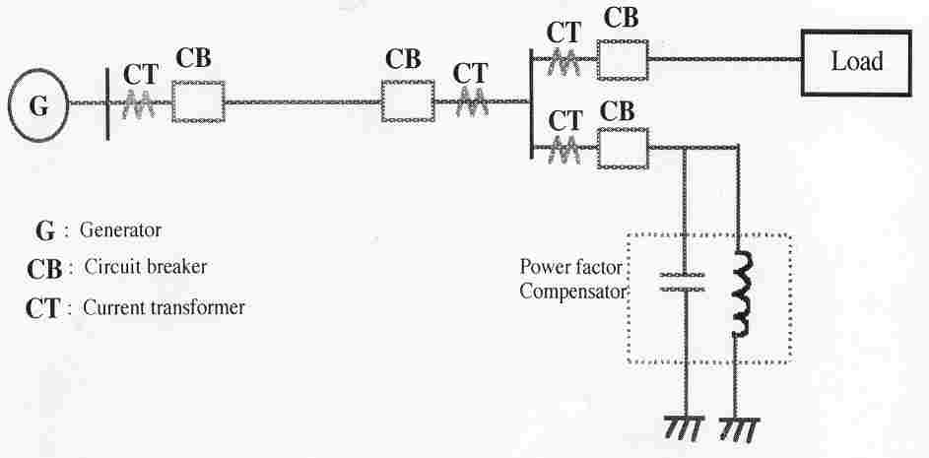
Figure 1. A typical electric power network

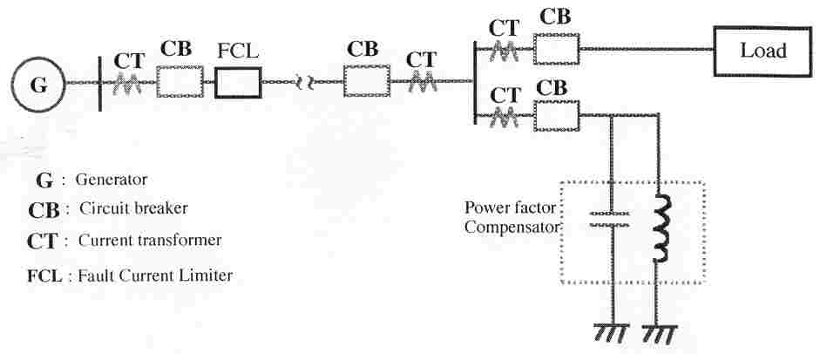
Figure 2. The electric power network with FCL in use

So what is desired is a device or system which can limit the fault current in the power system yet meet the following functional requirements,
- Limit the first peak of the fault current,
- Exhibits a low impedance and low energy losses in the normal state,
- Generate no unacceptable harmonics in the normal state,
- Eliminate sensors and control devices if their reliability compromises the overall reliability of the system,
- Exhibits a smooth and gradual change of impedance from the normal mode to fault mode and vice-versa,
- Compactness,
- Fail-safe operation,
- Zero reset time.
Of course it is difficult to meet all the above requirements in practice. The actual characteristics of the FCL should be as close as possible to the ideal requirement.

- TRADITIONAL WAYS OF FIXING FAULT CURRENT

The research and development of fault current limiter is as old as that of power systems. Earlier, most of the researches were not focused on limiting the fault current but basically on breaking the circuit to isolate the fault and thus prevent damage to costly equipment. Many approaches to limiting fault currents have been proposed in the past which include the use of circuit breakers with ultra-high fault current rating, high impedance transformers, current limiting fuses, air-core reactors, reconfiguration of the system such as splitting of power buses as presented in Table 1 [3]. None has proved to be efficient or economical. Usually circuit breakers are expensive, cannot interrupt fault currents until the first current comes to zero and have limited life times. The high impedance transformer with their high losses makes the system inefficient. The fuses have a very low withstandable fault current and it has to be replaced manually. The air-core reactors are subject to large voltage drops, incur substantial power loss during normal operation and require installation of capacitors for volt-ampere reactive (VAR) compensation. The system reconfiguration using bus-splitting besides adding cost reduces the system reliability and its operational flexibility.
Ibrahim [4] has reported a fault current limiter based on electromagnetic circuit consisting of an iron core and armature with adjustable air-gap. With normal load current, the device offers a minimum impedance at supply frequency. During fault conditions, the fault current is used to provide the necessary force needed to change the device inductance to the maximum impedance. Since the satisfactory performance of the current limiter is associated with the movement of the plunger, the reliability may be a problem.
Figure 3 shows the circuit diagram for a series tuned inductor-capacitor circuit [5]. Under normal conditions the switch is open and the capacitor in series with the inductor in both branches. The total impedance offered by the series branch at the line frequency is virtually zero. Under fault condition the switch is closed and the circuit impedance consists of an equivalent reactance in series with a resistance. The switching action can be accomplished through a spark gap which can be triggered by the potential appearing one of the capacitor. The drawbacks are its higher cost and large space requirement.

Table 1: Traditional ways of fixing fault current (IEEE Spectrum July 1997 issue)

Device | Advantages | Disadvantages
Circuit-breaker | * Proven  * Reliable | * Needs zero current to break  * Costs a lot and has limited lifetime
High-impedance transformer | * Widely used | * Breeds inefficiency in system (high losses)
Fuse | * Simple | * Breaks too often  * Must be replaced by hands
Air-core reactor | * Proven  * Traditional | * Entails large voltage drop  * Causes substantial power loss during normal operation
System reconfiguration  (bus splitting) | * Proven  * Preferred for fast-growing areas | * Reduces system reliability  * Reduces operating flexibility  * Adds cost of opening CBs

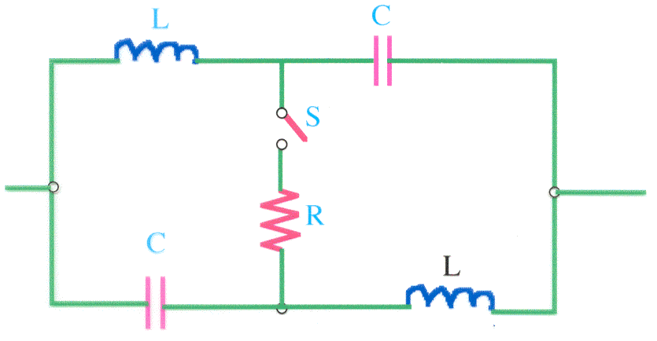
Figure 3. Tuned impedance current limiter
Figure 4 shows the circuit diagram of a silver-sand fuse used for current limiting. The commutation principle involves a simple, oil-filled bypass switch, which upon opening generates an arc voltage thus allowing the current in the arc to transfer into a parallel silver-sand fuse. The time taken for the fuse to melt is more than enough to allow for the ionized gas within the switch to deionize and for the switch to achieve its recovery potential. The fuse current is transferred to the nonlinear resistor once the fuse melts. One concern with this approach is that the electronics and cabling associated with the chemical actuator which are used to operate the bypass switch as well as to close the fuse switch must be adequately shielded.
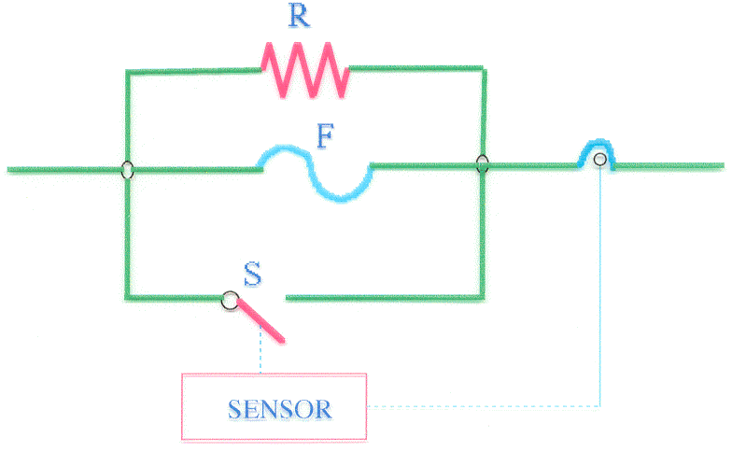
Figure 4. Single phase representation of silver-sand fuse FCL

A lot of research works carried out to limit fault currents in electronic circuits based on ICs [6, 7]. But in many cases they are limited to a few hundreds of mAs or a few amperes.
The existing fault current limiting devices/systems still fall short of addressing one or more of the following concerns: economic, current capacity, efficiency or reliability. Therefore there is currently a motivation to explore alternative approaches to fault current limiting.

IV. MAGNETIC CURRENT LIMITER (MCL)

a. Operating principle and construction of MCL
The operating principle of magnetic current limiter (MCL) is explained with the help of figure 5 [8]. The permanent magnet is sandwiched between the saturable core and is used to saturate the core under normal operating condition. The direction of the magnetomotive force and the alternating current is additive in core#1 and subtractive in core#2 at the same time. During normal condition during which the operating current is low, both the cores are under saturation. So the effective impedance of the system is low. During fault, the large value of current forces the cores to come out of saturation in alternate half-cycle, so unsaturated inductance of one core in combination with the saturated inductance of the other core restricts the flow of abnormally large value of fault current. Figure 6 shows the operating point of one core based on the B-H characteristics of the permanent magnet (PM) and core. In order to saturate the core such as ferrite, it should have a very low value of saturation flux density compared to PM. Figure 7 shows the complete flux-current characteristics of both the core-PM assembly.
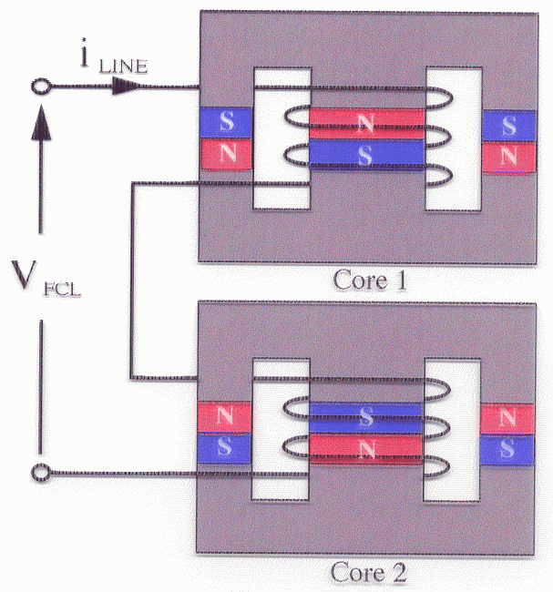
Figure 5. Basic structure of MCL

Based on the above principle different types of magnetic current limiter have been fabricated. The magnetomotive force of the PM and the coil may act in series or in parallel. Figure 8 shows a fabricated series biased limited based on ferrite core and permanent magnet made of Nd-Fe-B [9]. Figure 9 shows a fabricated parallel biased limiter based on steel core and permanent magnet [10]. The models shown in figures 8 and 9 are used for single phase system. Figure 10 shows a fabricated model for three-phase system based on ferrite core and ring type PM [11].

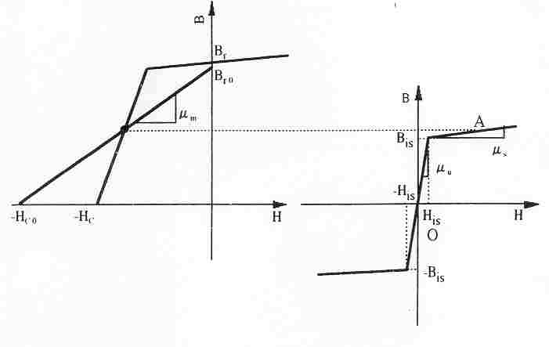
Figure 6. B-H characteristics and operating point
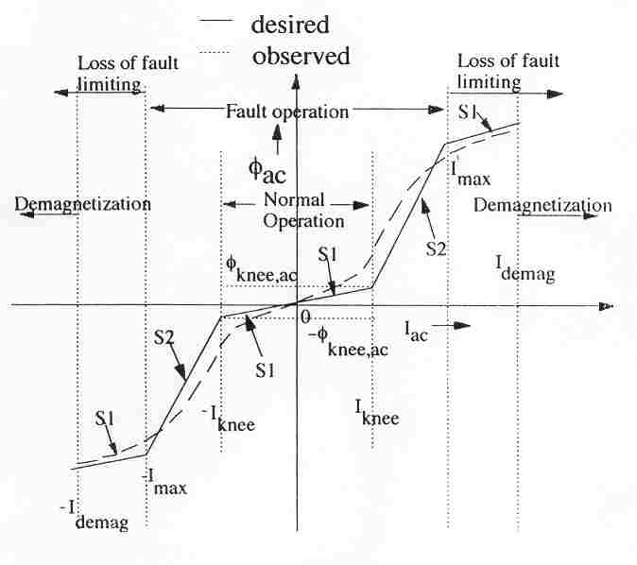
Figure 7. The φ-i characteristics of the complete system

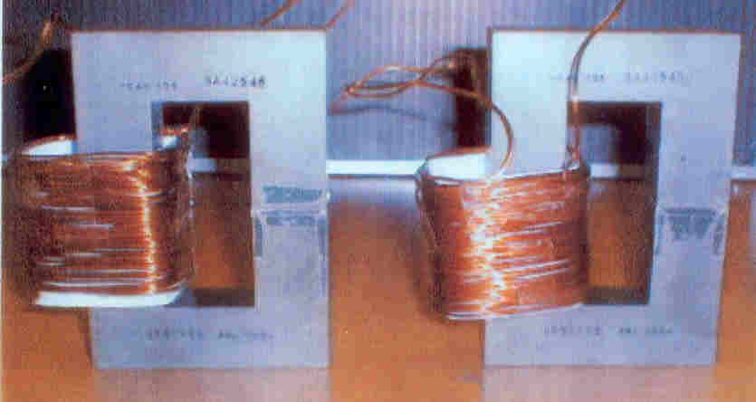

Figure 8. Series biased MCL based on ferrite core and permanent magnet

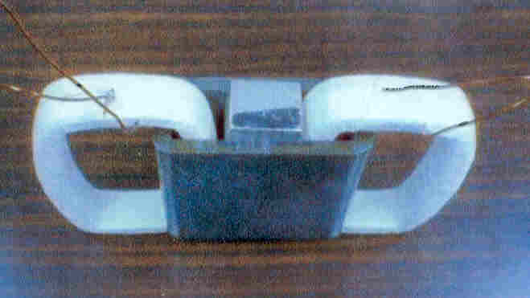

Figure 9. Parallel biased MCL based on steel core and permanent magnet

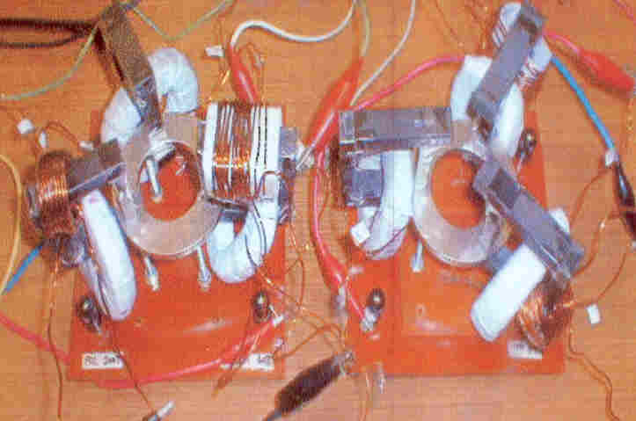

Figure 10. Series biased MCL based on ferrite core and ring type permanent magnet for three-phase system

b. Design Criterion and Application Areas Of MCL

The basic design criterion of magnetic curent limiter is explained in this section. During the fault condition to avoid the PM to be in the loss of current limting and demagntization zone as shown in figure 7, the following condition is to be satisfied.
(1)
where H_{c} is the coercive force of the PM and l_{m} is the length of the PM. I_{max} is the maximum current allowed during the fault condition. H_{c} is dictated by the PM itself, so PM with higher value of coercive force is to be selected. The minimum value of N, i.e. the turn of the coil may be 1. So the maximum value of current i.e. system level is dependent on the length of the magnet.
Under normal condition the voltage drop across the MCL is to be very low and is given by
(2)
The voltage across the MCL during fault condition to be very large and is given by
(3)
where L_{s} and L_{u} are the saturated and unsaturated inductance respectively and are given by
and (4a, b)
where R_{m}, R_{s} and R_{u} are the reluctance of PM, saturated reluctance of the core and unsaturated reluctance of the core respectively and are given by
, and (5a, b, c)
where S is the common area of the core or PM, μ_{m}, μ_{s} and μ_{u} are permeabilities of PM, saturated core and unsaturated core respectively.
Under fault condition the full voltage appears across the MCL.
So we can write V_{supply} = X_{u}I_{FAULT} (6)
So the ratio of the normal voltage drop across MCL to the supply voltage is given by
(7) ; k is the ratio of I_{FAULT} to I_{NOR}.
From (4a, b) and (5a, b, c) we can write
(8); the reluctance R_{u} is neglected with respect to R_{m}.
For NdFeB PM, the permeability and assuming l_{core}/l_{m} = 100, we get
(9); μ_{rs} is the relative permeability of the core under saturated condition. The variation of the ratio L_{u}/L_{s} as a function of μ_{rs} is shown in figure 11. It is seen that a higher value of L_{u}/L_{s} demands a very low value of saturated permeability, μ_{rs} of the core. It is difficult to get core with that low value of μ_{rs}. So with the available value of μ_{rs}, it is difficult o achieve a high value of L_{u}/L_{s} which means the voltage drop across the limiter under normal operating condition is quite large.
c. Applications of MCL
This type of limiter is suitable in power electronic based systems as shown in figures 12 and 13, in which the voltage across the load can be adjusted. Usually the magnetic current limiter are suitable for supply system of voltages up to 600 V and current up to a few hundreds of amperes. In figures 12 and 13 this type of limiter can be used to limit the fault during the failure of the power electronics devices such as transistors, diodes etc. and under short circuit.

Figure 11. The variation of L_{u}/L_{s} with μ_{rs}

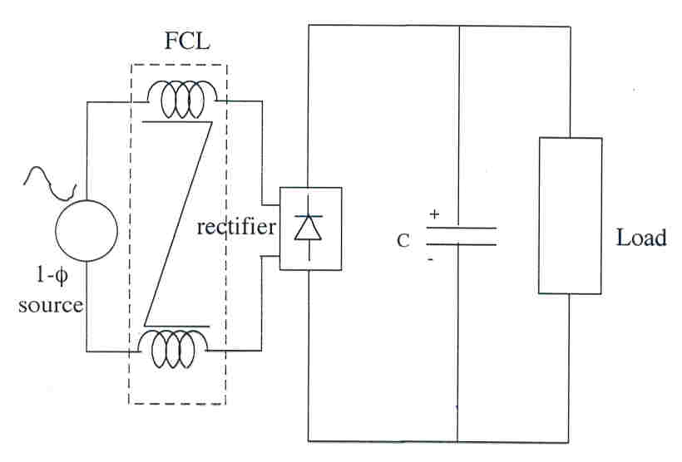
Figure 12. A typical single phase power electronic system for the application of MCL
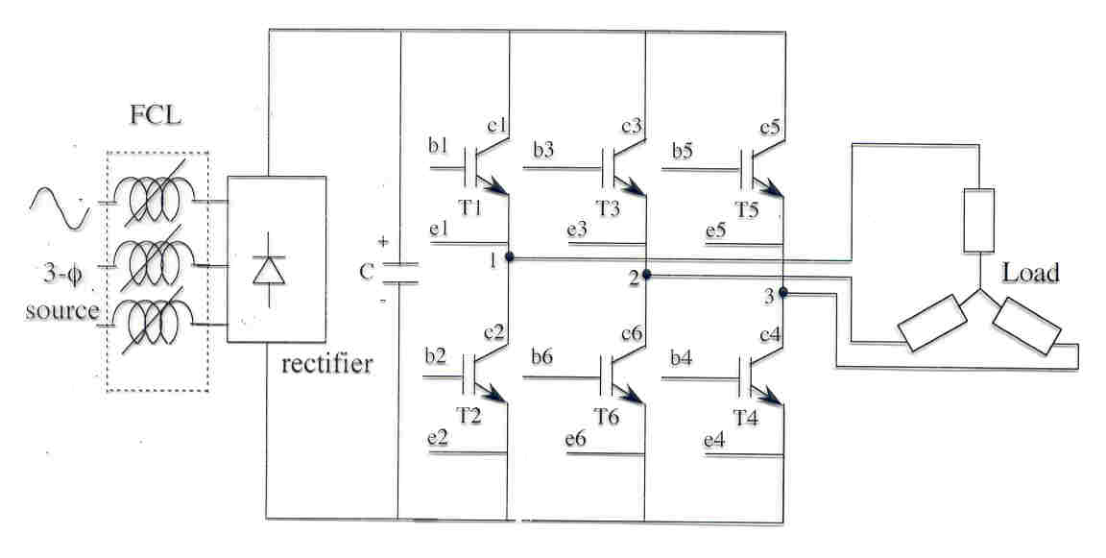
Figure 13. A typical three phase power electronic system for the application of MCL

d. Experimental results with MCL
The students can do experiments and verify the theory using the experimental set-up shown in figures 12 and 13. A few results are shown here. Figure 14 shows the starting line current with and without MCL for the circuit shown in figure 12 with a discharged capacitor. It is seen that in the absence of MCL the peak starting current reaches nearly 95 A. In contrast, the peak current with the MCL in place is 55 A. This is less than 200% of the nominal peak current.
Figure 14. Starting current waveforms with and without MCL

Figure 15 shows the current and voltage waveforms under a shorted diode condition. It is seen that the peak current is reduced considerably when the MCL is inserted.
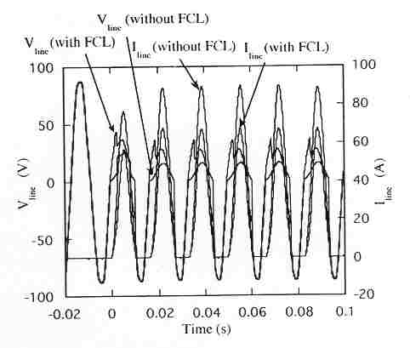
Figure 15. Current waveforms under a shorted diode condition
Figure 16 shows the line currents and voltage during shorted load condition. It is seen that the peak current is considerably less due to MCL.
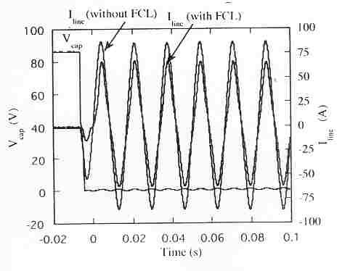
Figure 16. Current waveforms under shorted output condition

V. HIGH TEMPERATURE SUPERCONDUCTOR FAULT CURRENT LIMITER (HTSFCL)

a. Introduction
From the earlier discussion it has become very clear that the MCL cannot be used in all applications and not suitable for large system. In order to apply limiter for large capacity power system the use of high temperature superconducting fault current limiter [12, 13, 14, 15, 16, 17] is one of the viable option in present days. The superconducting material exhibiting zero resistance at the superconducting state and a high resistance at the normal state is an ideal element to make fault current limiter. The movement from the superconductivity to the normal conducting state can be rapid. In this concept of protection, a superconducting device is placed in parallel with an impedance element such as a resistor or reactor. Alternatively a similar arrangement can be facilitated by means of transformer coupling. Each of these methods are discussed in turn.

a.i Superconductive shunt with a resistive bypass element

Figure 17 shows the circuit diagram for a fault current limiter which uses a superconducting shunt. The resistor bypass element is designed to limit the fault current. The superconductor operates in a superconducting state until a fault current is detected. This fault current must be below the critical current level of the superconductor. It is desirable to choose a superconducting material which has a high resistivity in the non-superconducting state. In this way the current through the superconductor element can be minimized when it is forced into high resistance state. A switch may also be placed in series with the superconducting element so as to limit the amount of power dissipation when the superconducting element is in its high resistance state. The superconductor is switched into its off-state by either applying an external magnetic field or by uniformly illuminating the superconductor with an optical beam. The device cannot be switched too quickly otherwise it will be subjected to an overvoltage. On the other hand the device cannot be switched on too slowly otherwise fusing of the superconductor can occur. A superconducting device cannot recover its fault limiting properties instantaneously since the liquid cryogenic coolant must be cooled down to its prefault temperature. This could be of the order of tens of milliseconds. There will also be some insulation concerns at the edges of the superconducting device. The disadvantage to this approach is the high cost of refrigeration at temperature representing the liquid state of nitrogen. Refrigeration equipment will require maintenance and therefore the issue of reliability may be of concern. The cost of the sysem will increase as the continuous load current is increased. This stems from the increased heat leakage due to the larger area of the high current feedthrough. Another disadvantage of this device is that it is not self sensing.
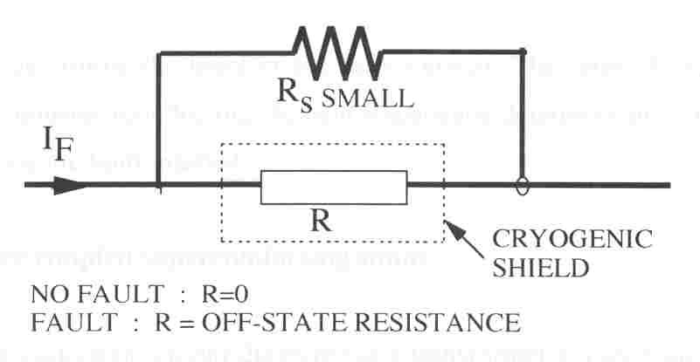
Figure 17. Superconducting FCL (resistive shunt type)

a.ii Superconducting shunt with an inductive bypass element

Figure 18 shows the circuit for a superconducting shunt with an inductive bypass element. The trigger coil consists of one coil wrapped over top of another coil. The coil geometry is designed to have a low coil inductance when the superconductor is in its superconducting state. Under normal operating conditions the current is insufficient to cause the superconductor to come out of its superconducting state. Thus the normal voltage drop across the trigger coil is quite low because of the minimum inductance design. However, if the current exceeds a critical value, the superconductor switches into its high resistance state. Most of the current flowing through the trigger coil is then transferred to the bypass element. The impedance of the coil in combination with the non-superconducting resistance of the trigger coil determine the level of the fault current. The ratio of the bypass impedance and the non-superconducting element impedance determine the current level in the trigger coil during the fault interval.

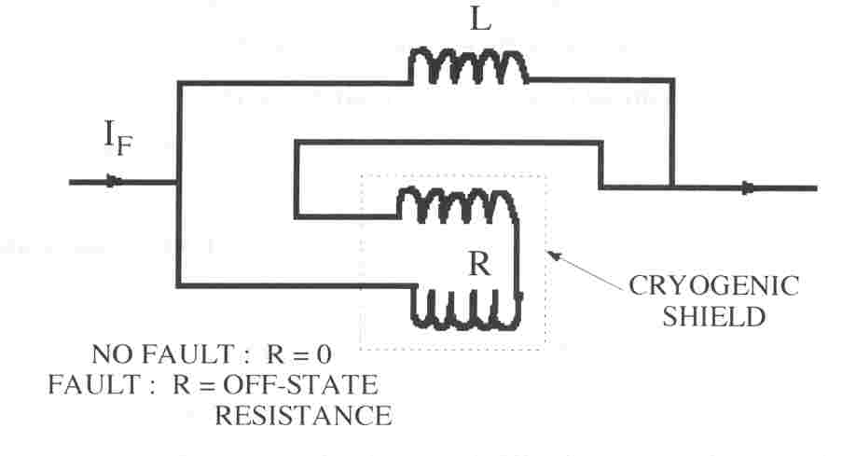
Figure 18. Superconducting FCL with an inductive bypass element

a.iii Transformer coupled superconducting shunt

Figure 19 shows the equivalent circuit diagram for a transformer coupled superconducting shunt. Under normal operating conditions the superconducting coil current prevents any magnetic field from existing within the interior of the inner coil. A small clearance between the inner coil and the outer coil results in a small inductance design. If a critical field current exceeded a certain value the superconductor will transfer to its high resistance state. Consequently flux penetrates into the centre of the coil. Thus the effective inductance seen by the coil and the transformer referred resistance of the coil increase. The increased impedance results in a current limiting action.
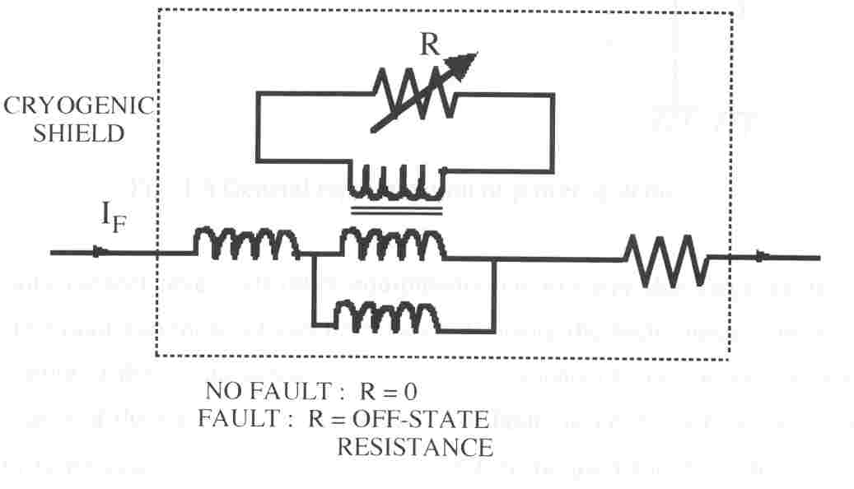
Figure 19. Transformer coupled superconducting shunt
b. Design criterion of HTSFCL
While designing and developing the HTSFCL the following points are considered.
(1) The V-I characteristic of the limiter from normal to fault state should give a large transition of resistance to limit the fault current.
- The voltage drop during normal condition should be very less, typically less than 1% is desirable.
- Since during the fault condition full voltage appear across the limiter, there will be considerable amount of power loss in the case of resistive type limiter. The power loss will increase the temperature. In order to get the recovery of the superconducting properties, the heat should be removed as early as possible.
(4) The soldering of the superconductor wire with the normal wire may introduce the contact drop/resistance.

A few more issues are to be considered.
- Material aspects – to find the best among Bi₂Sr₂CaCu₂O_{8+x} (Bi2212), Bi₂Sr₂Ca₂Cu₃O_{10+y} (Bi2223) and YBa₂Cu₃O_{6+z} (Y123).
- Limitation behavior, (7) Limitation time, (8) Recovery time, (9) Losses, (10) Overload capability, (11) Transient behavior – inrush current, (12) Power quality, (13) Coupling of Grids, (14) Connection of power stations, (15) Protection of auxiliary devices [18, 19].

c. Analysis Of HTSFCL

A short introduction of the method of analysis of HTSFCL is presented to the students. A meander patterned HTS wire has been considered to configure FCL. Figure 20 shows a schematic model along the cross-section of the FCL. The model has been discretized with many non-overlapping nodes.
The general non-steady thermal equation is known to be (10); K is the thermal conductivity, q* is the internal generated heat per unit volume, and C is the specific heat. The heat q* is given by q* = E.J (11) ; where E is the electric field intensity and J is the current density of the HTS wire.

Silver coating

HTS wire

Silver coating

Figure 20. Schematic of FCL for analysis

The steps of analysis of HTSFCL are divided into two states : (i) Normal condition and (ii) Fault condition. The relationship between the current density and the electric field intensity for both the conditions are discussed below.
Normal condition: In normal condition the current is decided by the external circuit parameters i.e., the load impedance. The current density, J, for the HTS wire is thus calculated dividing the current by the area. The electric field intensity of the HTS wire is thus given by [14]
(10); E_{o} = 1E-4 and b1 = 20.
The voltage across the HTS wire is thus obtained by multiplying the electric field intensity with the length.
Once the electric field intensity, E is obtained, the heat loss, E.J, is calculated. The temperature, T using the heat loss, is calculated based on the developed thermal model.
Fault condition: During the fault condition the full voltage appears across the FCL. So the electric field intensity is decided by the supply voltage and the length of the HTS wire. The current density of the HTS wire is a function of the operating temperature and the electric field intensity.
The temperature dependence of the critical current density is expressed as [14]
(12)
T_{c} and x for different HTS materials are given by
Ag/Bi-2223: T_{c} = 105-110 K x = 1.4
Ag/Bi-2212: T_{c} = 85-92 K x = 1.8
Y-123: T_{c} = 88 K x = 1.2
Based on the operation at 77 K with liquid nitrogen the current density during fault condition is given by
(13)
The current density of each node is thus calculated and the current of each section is obtained multiplying the corresponding area associated with each node. The total current is calculated by taking the sum of all the current along the cross-section of the HTS wire.

d. Simulation results
Some simulation results are presented so that the students will learn the effect of different parameters on the performance of HTSFCL. Figure 21 shows the temperature distribution along the depth of the HTS wire for different values of electric field intensity. The higher value of E will produce higher temperature rise but the required length of wire will be shorter and consequently reduction in cost. Figure 22 shows a current vs time characteristics for a typical fault condition with different values of E. It is seen that the fault current becomes larger with the large values of E. Figure 23 shows the variation of temperature with time for different values of E.

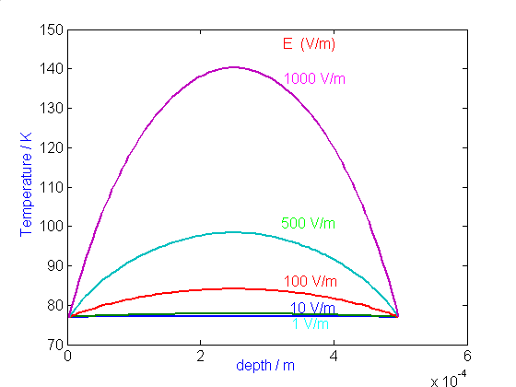
Figure 21. Temperature distribution along the depth for various E’s
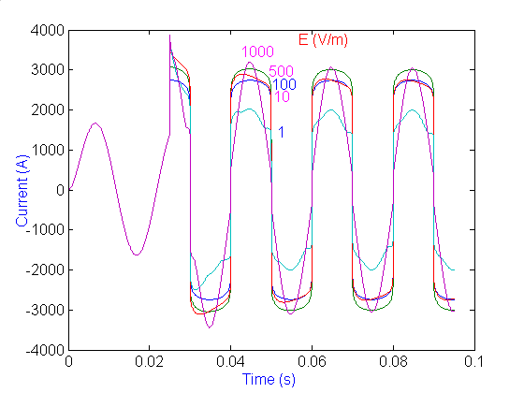
Figure 22. Current versus time characteristics
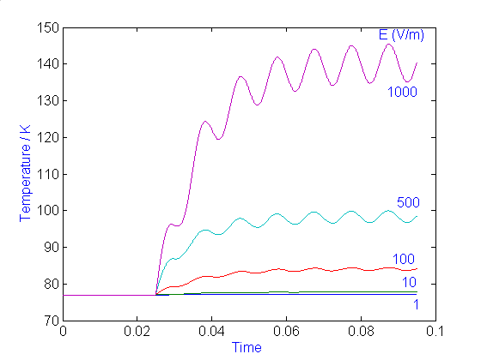
Figure 23. Temperature versus time characteristic

Figure 24 shows the variation of current with time for different values of critical current density, J_{c}. It is seen that the HTS material with higher J_{c} allows larger fault current to flow. The higher values of J_{c} will allow less cross-sectional area of the HTS material.
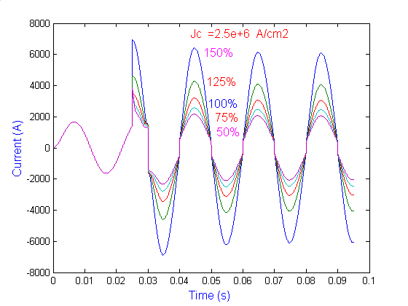
Figure 24. Variation of fault current with time for different values of Jc
Figure 25 shows the final value of temperature almost 4 cycles after fault with different values of depth of the limiter. It is seen that the final value of temperature is higher for larger value of depth of the HTS wire. A lot of other conditions have been simulated and presented to students.

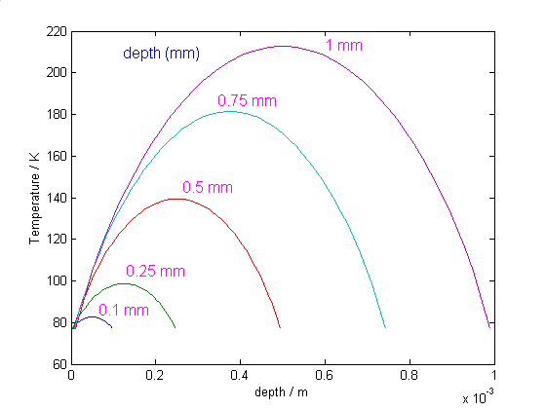
Figure 25. Variation of fault current with time for depth

e. Experimental results
A small length of HTS materials has been fabricated in the laboratory and the T-J characteristics for different values E has been experimented. Figure 26 shows the experimental T-J characteristics of a typical HTS wire. It is seen for higher value of E, the critical current density J_{c} doesn’t change much with temperature.

Figure 26. Experimental T-J characteristics of HTS wire

VI. CONCLUSIONS

This paper is a one-hour lecture on the topic of fault current limiter presented to engineering students. The lecture has started with the causes and effects of fault on power systems. The traditional ways of fixing fault current have been described. The detailed analysis of two types of fault current limiters: based on magnetic materials and high temperature superconductor materials have been presented. With some modification (elimination of mathematical part) the lecture can be presented to general public.

REFERENCES

[1] S.N.Talukdar, J. Apt, M.Ilic, L.B.Lave and M.G.Morgan, “Cascading Failures: Survival versus Prevention”, The Electricity Journal, Elsevier Inc., November 2003, pp. 25-31.
[2] D. White, A. Roschelle, P.Peterson, D.Schlicel, B.Biewald and W.Steinhurst, “The 2003 Blackout: Solutions that won’t Cost a Fortune”, The Electricity Journal, Elsevier Inc., November 2003, pp. 43-53.
[3] E. Leung, “Surge Protection for Power Grids”, IEEE Spectrum, July 1997, pp. 26-30.
[4] E. S. Ibrahim, “Electromagnetic Fault Current Limiter”, Electric Power System Research, Vol. 42, 1997, pp. 189-194.
[5] V.H.Tahiliani and J.W.Porter, “Fault Current Limiters – An Overview of EPRI Research”, IEEE Transactions on Power Apparatus and Systems, Vol. PAS-99, no. 5, 1980, pp. 1964-1969.
[6] “Simple Current Limiter for DC 2770- Based Charger”, Maxim Application Note 2044, Dallas Semiconductor (ww.maxim-ic.com/an2044), 2003.
[7] “Flexible Hot-Swap Current Limiter Allows Thermal Protection”, Maxim Application Note 390, Dallas Semiconductor (ww.maxim-ic.com/an390), 2001.
[8] S.C.Mukhopadhyay, “Synthesis and Implementation of Magnetic Current Limiter”, Doctor of Engineering thesis, Faculty of Engineering, Kanazawa University, Japan, March 2000.
[9] S.C.Mukhopadhyay, M.Iwahara, S.Yamada and F.P.Dawson, " Analysis, design and experimental results for a passive current limiting device", IEE proceeding on Electric Power Applications, vol. 146, no. 3, pp. 309-316, May 1999.
[10] M.Iwahara, S.C.Mukhopadhyay, S.Yamada and F.P.Dawson, "Development of passive fault current limiter in parallel biasing mode", IEEE transc. on Magnetics, Vol. 35, No. 5, pp 3523-3525, September 1999.
[11] S.C.Mukhopadhyay, F.P.Dawson, M.Iwahara and S.Yamada, “A novel compact magnetic current limiter for three phase applications”, IEEE transc. on Magnetics, Vol. 36, No. 5, pp. 3568-3570, September 2000.
[12] P. Malkin and D. Klaus, “Cap That Current”, IEE Review, March 2001, pp. 41-45.
[13] W.Paul, et.al., “Test of 1.2 MVA high-Tc superconducting fault current limiter”, Proc. On Superconducting Sci. Technol., IOP Publishing Ltd., 10 (1997), 914-918.
[14] G.E.Marsh and A.M.Wolsky, “AC losses in high-temperature superconductors and the importance of these losses to the future use of HTS in the power sector”, Report submitted to International Energy Agency, USA, May 2000.
[15] M. Steurer, H. Brechna and K. Frohlich, “A Nitrogen Gas Cooled, Hybrid High Temperature Superconducting Fault Current Limiter”, IEEE Transactions on Applied Superconductivity, vol. 10, No. 1, 2000, pp. 840-844.
[16] T. Ohnishi, N. Aizawa, A.Yamagata, A. Nii and M.Shibuya, “Stability of a Shorted Nb3n Coil Cooled by a Refrigeration for a Magnetic Shield Type Fault Current Limiter”, IEEE Transactions on Applied Superconductivity, vol. 10, No. 1, 2000, pp. 845-848.
[17] V. Keilin, I. Kovalev, S.Kruglov, V.Stepanov, I.Shugaev and V.Shcherbakov, “Model of HTS Three-Phase Saturated Core Fault Current Limiter”, IEEE Transactions on Applied Superconductivity, vol. 10, No. 1, 2000, pp. 836-839.
[18] S.C.Mukhopadhyay, C.Goonaratne, M.Staines, I.Vajda, M.Iwahara and S.Yamada, “Feasibility study of developing high temperature superconducting fault current limiter: A New Zealand perspective”, Proc. ISEM 2003, pp. 100-101, France, May 12-14, 2003.
[19] S.C.Mukhopadhyay, C. Gooneratne and M. Staines, “Transition of magnetic current limiter to superconducting fault current limiter”, Proceeding of AUPEC conference, paper no. 3, Sep. 28- Oct. 1, 2003, Christchurch, New Zealand.

